# Title

Easy select of all dates for a given month in RadCalendar for ASP .NET Ajax

# Description

Currently RadCalendar allows the easy selection of all dates for a given week or all dates on a given week day (for example all Mondays). This is done by clicking on the week number (on the left) or respectively clicking on the week day letter (at the top).

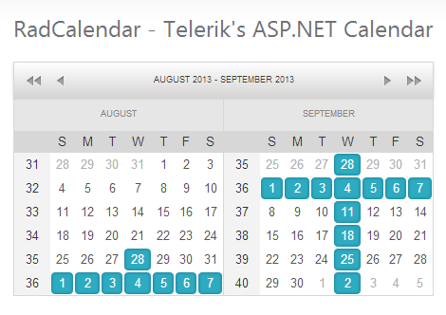

It would be useful to be able to select all days for a given month by clicking on the left-top corner of the calendar (Case1) or on the name of the month (Case2).

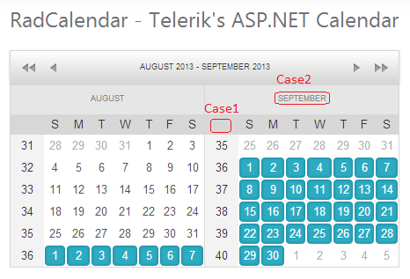

# Use cases to support

Adding this function will allow the user to easily select all days of the month if he wants to operate with all of them together.

This feature will also be useful if the user wants to select most of the days in the month – he will be able to select all days and then deselect the unnecessary ones.